**WP4**

**D4.1.1**

**Knowledge Base Design document**

ModelWriter

Text & Model-Synchronized Document Engineering Platform

Work Package: WP4

Task: T4.1 – Knowledge Base Design

Edited by:

Erhan Mengusoglu <erhanmengusoglu@mantis.com.tr> (Mantis)

…

Date: 02-Jun-2015

Version: 1.0.0

Apart from the deliverables which are defined as public information in the Project Cooperation Agreement (PCA), unless otherwise specified by the consortium, this document will be treated as strictly confidential.

Document History

|  |  |  |  |
| --- | --- | --- | --- |
| Version | Author(s) | Date | Remarks |
| 0.1.0 | Ferhat Erata  Moharram Challenger | 30-Apr-2015 | Draft |
| 1.0.0 | Erhan Mengusoglu | <date> | Initial Release |
|  |  |  |  |

Table of Contents

Contents

Document History 2

1. Introduction 4

2. Definition of knowledge base and sample elements 5

3. Sample RDF representation of ModelWriter use cases 6

4. Representation of ontological structures in the knowledge base 7

5. Conclusion 8

References 9

Appendixes 10

Appendix 1 **Error! Bookmark not defined.**

1. Introduction

This deliverable provide basic design principles for the knowledge base which serves as the repository for metamodels.

|  |  |
| --- | --- |
| Abbreviation | Definition |
| RDF | Resource Description Framework |
| WP | Work Package |
| UC | Use Case |

1. Definition of knowledge base and sample elements

Knowledge is defined as “Facts, information, and skills acquired through experience or education; the theoretical or practical understanding of a subject” by the Oxford dictionary. In the context of the project we will take the part “theoretical or practical understanding of a subject” from this definition. In digital environment, knowledge is represented as a network of semantic definition for a particular subject using a semantic web approach.

Semantic web is originally an approach defined by W3 Consortium for creating digitally readable structures for web pages on the internet. This well-defined methodology for representing the data on web pages, later on, found to be useful for representing knowledge in different domains like biology, banking, astronomy etc.

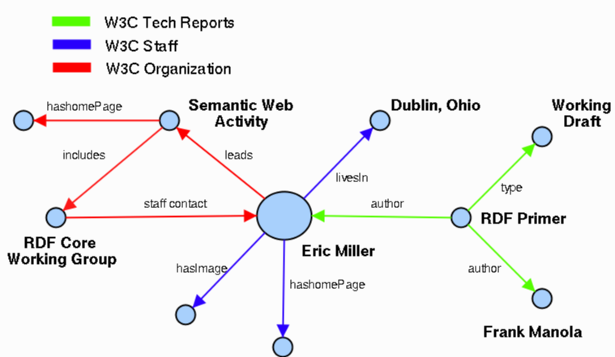An example semantic web is provided below:

In the project, model elements need to comply the notation of semantic web usually described as Resource Description Framework (RDF) documents. W3C describe RDF structures as “the underlying structure of any expression in RDF is a collection of triples, each consisting of a subject, a predicate and an object”.

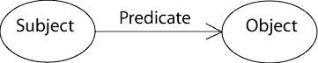

In this notation, direction of the arc between subject and object is significant.

ModelWriter will use RDF as the meta-model for knowledge-base. By imposing the model elements to comply with RDF notation we will have standardized representation of text documents as models.

1. Sample RDF representation of ModelWriter use cases

UC-TR-01 – to be provided later when the first attempt to create the model for this use case has been completed.

UC-FR-01 – to be provided later when the first attempt to create the model for this use case has been completed.

1. Representation of ontological structures in the knowledge base

Ontological structures are represented as RDF documents in the knowledge base.

1. Conclusion

This deliverable will serve as a reference document for designing and implementing model to text and text to model transformations. Bases for synchronizing models with texts and vice versa are also provided in this document.

References

1. Wang, Xiao Hang, et al. "Ontology based context modeling and reasoning using OWL." Pervasive Computing and Communications Workshops, 2004. Proceedings of the Second IEEE Annual Conference on. Ieee, 2004..
2. <http://www.cs.uu.nl/docs/vakken/b3ii/Intelligente%20Interactie%20literatuur/College%205.%20Context%20Awareness%20en%20Ubiquitous%20Computing%20(Dignum)/Ontology%20for%20contexts%20(verplicht).pdf>

Appendixes

N/A